Deploying apps into Docker container

Git hub repo: https://github.com/rajbirsood/training-project
- Create Docker file which include instruction for container
Sample dockerfile looks like below.

FROM alpine
MAINTAINER <abc@gmail.com>
FROM python:2.7.9

env UBER_CLIENT_ID=<yourID>
env UBER_CLIENT_SECRET=<yourID>

COPY requirements.txt /tmp
COPY . /tmp
WORKDIR /tmp
RUN pip install --upgrade pip && \
pip install -r requirements.txt

ENTRYPOINT ["python","/tmp/app.py","/bin/bash"]
NOTE : requirement.txt, app.py Thease files are application specified files. Files are in the same location of docker file / Provide path for the file.

- Create the image from the dockerfile.

docker build –t <tage name> /dockerfilefolder path/
- For standalone docker container, image name “anhegde2/project-for-docker:v1”
- For kubernetes, we have used “anhegde2/training-project:v1”

ex. docker build -t training-project:v1 .
- OR pull image from docker hub.
docker pull anhegde2/project-for-docker:v1
- Run the docker image to create the docker container.

docker run -it -d <imagename:tag>

- Check if the container is running

docker ps

- Get shell for running container
docker exec -it <cinatiner_id> /bin/bash

- curl the endpoint inside container to check for the application output.
curl http://localhost:7000/

Deploying apps into Kubernetes clusters
- Create configmap using below command.
Kubectl apply -f configmap.yml
- Create secret using below command
Kubectl create -f secret.yml
- Create the deployment file to create pod inside cluster
Create deployment using below command.

kubectl create -f deployment.yaml

- Get running pod
Kubectl get pods
- Get executable shell for the pod.
kubectl exec -it --namespace=<namespace name> <podname> -- /bin/bash
- Run below command to check the details of the deployment
- kubectl describe deployment

- Create the service file to expose application as service to access the application from outside.
Create service using below command.

kubectl apply -f service.yml
and access the application from the browser
http://<hostname>:<nodeport>/
A Helm Package for the deployment
We have added helm chart for deployment
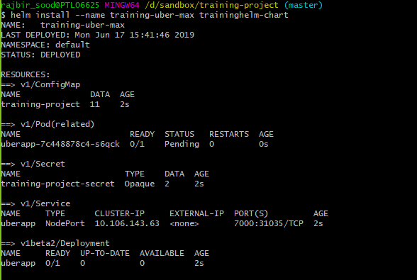
Command to run helm

- helm init --upgrade
- helm lint traininghelm-chart
- helm install --name training-uber-max traininghelm-chart

To redeploy if there are some changes
- helm upgrade training-uber-max traininghelm-chart

To delete helm chart
- helm del --purge training-uber-max

